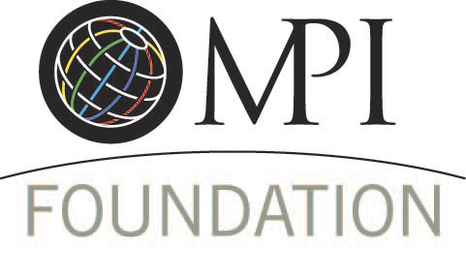

Conference Scholarships with Specific Criteria

Larry Lee Memorial Scholarship Program
Supported by Encore Productions, Freeman and friends of Larry Lee, The Larry Lee Memorial Scholarship is designed to allow recipients to experience the professional development and networking at the:
- IMEX Frankfurt 2016, April 19-21
- WEC 2016, June 11-14
- IMEX America 2016, October 18-20
- EMEC 2017 Granada, March 5-7
Scholarship Award
- Scholarship – up to $2,800 - will include registration to WEC, hotel accommodations up to 4 nights, economy airfare and a daily per diem.
- Scholarship funds will be paid directly to the providers and/or post-event as reimbursement to recipient upon the submission of proper receipts.
Scholarship Eligibility:
- Candidate must be an MPI student member and be in good standing with MPI at the time of application.
- Recipient will be expected to participate in the Future Leaders Forum during the respective conference as part of the scholarship.

Orange County Convention Center Scholarship
This scholarship is open to any University of Central Florida student currently enrolled in the Rosen College of Hospitality Management program. One full scholarship to attend WEC 2016 in Atlantic City will be awarded. Additionally, the Orange County Convention Center will sponsor the President of the Rosen College Student MPI Club to attend WEC.
Scholarship Award
- Scholarship – up to $2,800 - will include registration to WEC, hotel accommodations up to 4 nights, economy airfare and a daily per diem.
- Scholarship funds will be paid directly to the providers and/or post-event as reimbursement to recipient upon the submission of proper receipts.
Scholarship Eligibility
- Applicant must be a current student in the Rosen College of Hospitality Management at the University of Central Florida.
- Must be an MPI student member in good standing.

Wyndham Worldwide WEC Scholarship
This scholarship supported by Wyndham Worldwide will provide ten (10) educational scholarships to WEC.

- 5 faculty member scholarships
- 3 North American student member scholarships
- 2 international student member scholarships

Scholarship Award
- Scholarship will include registration to WEC, hotel accommodations up to 4 nights, airfare and a daily per diem.
- Scholarship funds will be paid directly to the providers and/or post-event as reimbursement to recipient upon the submission of proper receipts.

Faculty Scholarship Eligibility
- Must be faculty employed full time at a 2 or 4 year academic institution.
- Applicant should teach a minimum of 4 meeting management related courses per academic year (minimum 2 per semester).
- Preference given to current MPI faculty members in good standing.
- Preference given to current MPI student club advisors or commitment to serve as future MPI student club advisor.
- Application includes a short essay about how attending WEC will impact your career.
Student Scholarship Eligibility
- Must be an MPI student member in good standing.
- Must be a full time student in a 2 or 4 year institution with a major directly related to the meeting and event industry - verified by faculty member or department chair.
- Minimum grade point average – 3.0 on a US 4.0 scale.
- Must have completed a minimum of two semesters or four (4) industry-specific courses.
- Preference will be given to MPI student club members.
- Preference will be given to MPI student club officers or officer-elects (verified by faculty advisor).
- Application includes letter of recommendations from a faculty member and an MPI member and a short essay or video describing how MPI has influenced your life and how attending WEC will impact your education and future career.

NEWMARKET Scholarship
The Newmarket Scholarship will provide registration funding for recipients to attend the 2016 Newmarket Customer Conference.
May 17-20
The LINQ Hotel & Casino
Las Vegas, Nevada
The annual Newmarket Customer Conference welcomes hospitality professionals, customers, employees and partners to collectively reunite for a new look at the hospitality industry. The conference is specifically designed to provide attendees with the opportunity to network and collaborate with industry professionals, engage with thought-leaders, and gain valuable skills to help you succeed in the exciting future of the hospitality industry. For more information please visit http://www.newmarketinc.com/events-conferences/customer-conference.
Scholarship Eligibility
- Candidate must be an MPI planner member and be in good standing with MPI at the time of application.
- Scholarship recipient agrees to use of their name by MPI Foundation and Newmarket for promotional use, including optional photo use.
Scholarship Award
- The scholarship provides complimentary registration to the AHTC conference only.
- Recipients will be responsible for their own airfare and accommodation.

